

**UNIVERSITI MALAYSIA TERENGGANU**

**FACULTY OF COMPUTER SCIENCE AND MATHEMATICS**

**­­­­________________________________________________________**

**CSM3123 - NATIVE MOBILE PROGRAMMING**

**BANCHELOR OF COMPUTER SCIENCE (MOBILE COMPUTING) WITH HONORS**

**LAB 2 (Task 1,2,3,4,5)**

**SEMESTER 5 2024/2025**

**________________________________________________________**

**PREPARED FOR:**

**DR RABIEI B MAMAT**

**PREPARED BY:**

**NUR EZREENA SHUHADA BT EMRAN**

**S66467**

**Task 1 – LayoutExploration**

MainActivity.java

|  |
| --- |
| package com.example.layoutexploration;  import android.content.Intent; import android.os.Bundle; import android.widget.Button;  import androidx.activity.EdgeToEdge; import androidx.appcompat.app.AppCompatActivity; import androidx.core.graphics.Insets; import androidx.core.view.ViewCompat; import androidx.core.view.WindowInsetsCompat;  public class MainActivity extends AppCompatActivity {  @Override  protected void onCreate(Bundle savedInstanceState) {  super.onCreate(savedInstanceState);  setContentView(R.layout.*activity_main*);  Button linearLayoutButton =  findViewById(R.id.*linearLayoutButton*);  linearLayoutButton.setOnClickListener(v -> {  Intent intent = new Intent(MainActivity.this,  LinearLayoutActivity.class);  startActivity(intent);  });  Button relativeLayoutButton =  findViewById(R.id.*relativeLayoutButton*);  relativeLayoutButton.setOnClickListener(v -> {  Intent intent = new Intent(MainActivity.this,  RelativeLayoutActivity.class);  startActivity(intent);  });  Button constraintLayoutButton =  findViewById(R.id.*constraintLayoutButton*);  constraintLayoutButton.setOnClickListener(v -> {  Intent intent = new Intent(MainActivity.this,  ConstraintLayoutActivity.class);  startActivity(intent);  });  Button gridLayoutButton =  findViewById(R.id.*gridLayoutButton*);  gridLayoutButton.setOnClickListener(v -> {  Intent intent = new Intent(MainActivity.this,  GridLayoutActivity.class);  startActivity(intent);  });  } } |

Activity_main.xml

|  |
| --- |
| <?xml version="1.0" encoding="utf-8"?> <androidx.constraintlayout.widget.ConstraintLayout xmlns:android="http://schemas.android.com/apk/res/android"  xmlns:app="http://schemas.android.com/apk/res-auto"  xmlns:tools="http://schemas.android.com/tools"  android:id="@+id/main"  android:layout_width="match_parent"  android:layout_height="match_parent"  tools:context=".MainActivity">   <LinearLayout  android:layout_width="match_parent"  android:layout_height="match_parent"  android:orientation="vertical"  android:padding="16dp">   <TextView  android:layout_width="wrap_content"  android:layout_height="wrap_content"  android:text="Choose a Layout Type"  android:layout_gravity="center"  android:textSize="24sp"  android:padding="15dp"  android:layout_marginVertical="30dp"/>   <Button  android:id="@+id/linearLayoutButton"  android:layout_width="match_parent"  android:layout_height="wrap_content"  android:text="Linear Layout"  android:backgroundTint="#FF5722"/>   <Button  android:id="@+id/relativeLayoutButton"  android:layout_width="match_parent"  android:layout_height="wrap_content"  android:text="Relative Layout"  android:backgroundTint="#2196F3"/>   <Button  android:id="@+id/constraintLayoutButton"  android:layout_width="match_parent"  android:layout_height="wrap_content"  android:text="Constraint Layout"  android:backgroundTint="#4CAF50"/>   <Button  android:id="@+id/gridLayoutButton"  android:layout_width="match_parent"  android:layout_height="wrap_content"  android:text="Grid Layout"  android:backgroundTint="#FFC107"/>   </LinearLayout>   <TextView  android:id="@+id/copyrightTextView"  android:layout_width="wrap_content"  android:layout_height="wrap_content"  android:text="© 2024 Ezreena"  android:textSize="14sp"  android:layout_marginBottom="16dp"  app:layout_constraintBottom_toBottomOf="parent"  app:layout_constraintStart_toStartOf="parent"  app:layout_constraintEnd_toEndOf="parent"/>   </androidx.constraintlayout.widget.ConstraintLayout> |

Output:

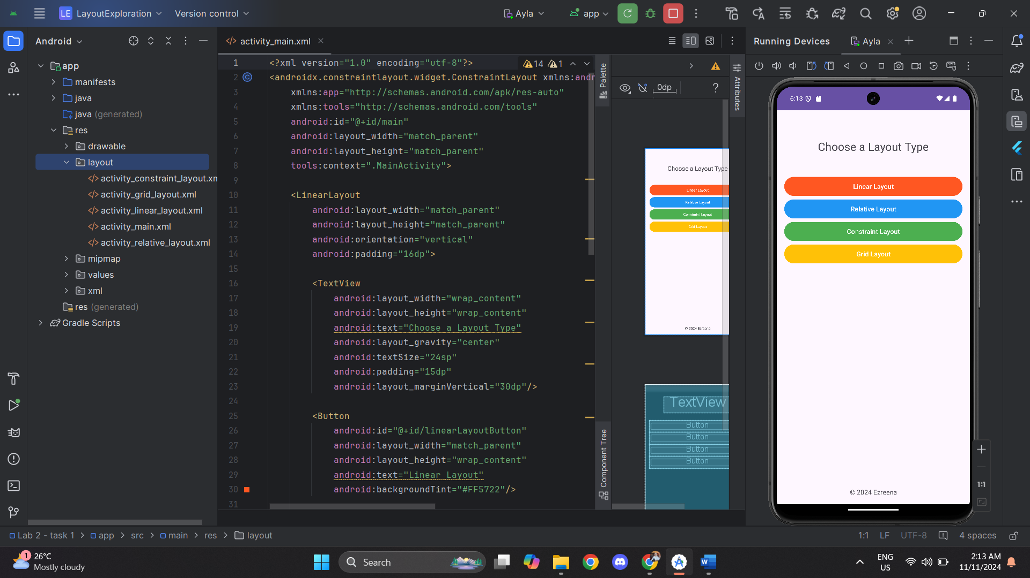

LinearLayout.java

|  |
| --- |
| package com.example.layoutexploration;  import android.os.Bundle; import android.widget.ArrayAdapter; import android.widget.Spinner; import androidx.appcompat.app.AppCompatActivity; import androidx.core.graphics.Insets; import androidx.core.view.ViewCompat; import androidx.core.view.WindowInsetsCompat;  public class LinearLayoutActivity extends AppCompatActivity {   @Override  protected void onCreate(Bundle savedInstanceState) {  super.onCreate(savedInstanceState);  setContentView(R.layout.*activity_linear_layout*);   // Define options directly in code  String[] options = {"FSKM", "FPSM", "FTKK", "FSSM"};  ArrayAdapter<String> adapter = new ArrayAdapter<>(this, android.R.layout.*simple_spinner_item*, options);  adapter.setDropDownViewResource(android.R.layout.*simple_spinner_dropdown_item*);   // Reference to the Spinner and set the adapter  Spinner optionsSpinner = findViewById(R.id.*optionsSpinner*);  optionsSpinner.setAdapter(adapter);   // Apply window insets to handle system bars and make the content display correctly  ViewCompat.*setOnApplyWindowInsetsListener*(findViewById(R.id.*main*), (v, insets) -> {  // Get the insets for system bars (status bar, navigation bar, etc.)  Insets systemBars = insets.getInsets(WindowInsetsCompat.Type.*systemBars*());  // Set the padding to avoid overlapping with system bars  v.setPadding(systemBars.left, systemBars.top, systemBars.right, systemBars.bottom);  return insets.consumeSystemWindowInsets(); // Indicate that system bar insets have been consumed  });  } } |

Activity_linearlayout.xml

|  |
| --- |
| <?xml version="1.0" encoding="utf-8"?> <androidx.constraintlayout.widget.ConstraintLayout xmlns:android="http://schemas.android.com/apk/res/android"  xmlns:app="http://schemas.android.com/apk/res-auto"  xmlns:tools="http://schemas.android.com/tools"  android:id="@+id/main"  android:layout_width="match_parent"  android:layout_height="match_parent"  tools:context=".MainActivity">   <!-- LinearLayout Section (Vertical orientation) -->  <LinearLayout  android:layout_width="match_parent"  android:layout_height="wrap_content"  android:orientation="vertical"  android:padding="16dp"  app:layout_constraintTop_toTopOf="parent"  app:layout_constraintStart_toStartOf="parent"  app:layout_constraintEnd_toEndOf="parent">   <!-- Title TextView -->  <TextView  android:layout_width="wrap_content"  android:layout_height="wrap_content"  android:text="LinearLayout Example"  android:textSize="24sp"  android:textStyle="bold"  android:padding="8dp"  android:layout_marginBottom="16dp"  android:textColor="#3F51B5"/>   <!-- ImageView for Displaying an Icon or Image -->  <ImageView  android:id="@+id/iconImageView"  android:layout_width="100dp"  android:layout_height="100dp"  android:src="@drawable/waves"  android:contentDescription="App Icon"  android:layout_gravity="center"  android:layout_marginBottom="16dp" />  <!-- EditText for Username -->   <EditText  android:id="@+id/usernameEditText"  android:layout_width="match_parent"  android:layout_height="wrap_content"  android:hint="Enter your name"  android:padding="10dp"  android:background="@android:drawable/editbox_background"  android:layout_marginBottom="16dp" />       <!-- Spinner for Selecting Options -->  <Spinner  android:id="@+id/optionsSpinner"  android:layout_width="match_parent"  android:layout_height="wrap_content"  android:layout_marginBottom="16dp" />   <!-- Button to Submit the Form -->  <Button  android:layout_width="wrap_content"  android:layout_height="wrap_content"  android:text="Submit"  android:layout_gravity="center"  android:textColor="#FFFFFF"  android:layout_marginBottom="16dp"/>   </LinearLayout>   <!-- Copyright TextView Centered at the Bottom -->  <TextView  android:id="@+id/copyrightTextView"  android:layout_width="wrap_content"  android:layout_height="wrap_content"  android:text="© 2024 Ezreena"  android:textSize="14sp"  app:layout_constraintBottom_toBottomOf="parent"  app:layout_constraintStart_toStartOf="parent"  app:layout_constraintEnd_toEndOf="parent"  android:layout_marginBottom="16dp"/>  </androidx.constraintlayout.widget.ConstraintLayout> |

Output:

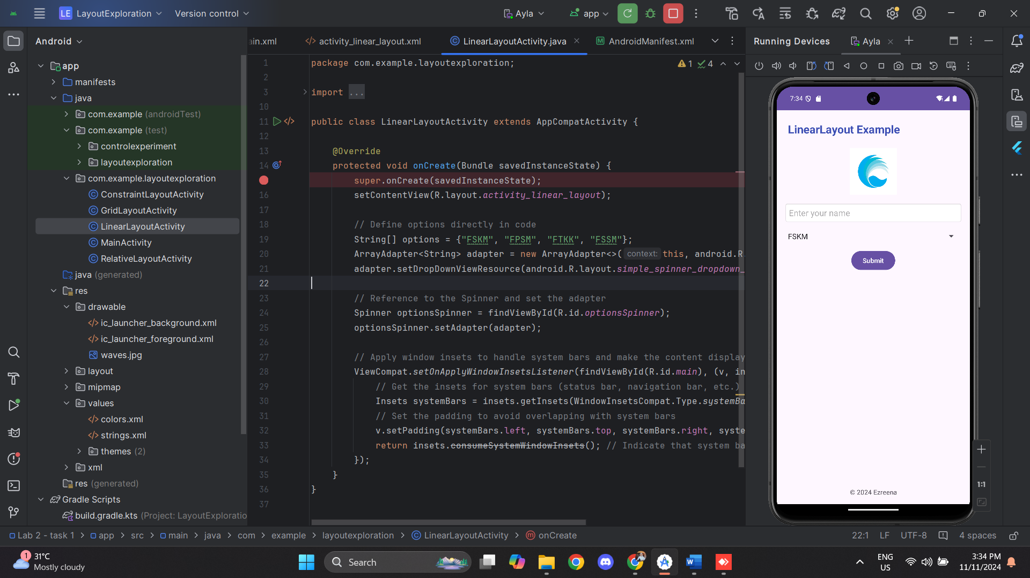

RelativeLayout.java

|  |
| --- |
| package com.example.layoutexploration;  import android.os.Bundle;  import androidx.activity.EdgeToEdge; import androidx.appcompat.app.AppCompatActivity; import androidx.core.graphics.Insets; import androidx.core.view.ViewCompat; import androidx.core.view.WindowInsetsCompat;  public class RelativeLayoutActivity extends AppCompatActivity {   @Override  protected void onCreate(Bundle savedInstanceState) {  super.onCreate(savedInstanceState);  EdgeToEdge.*enable*(this);  setContentView(R.layout.*activity_relative_layout*);  ViewCompat.*setOnApplyWindowInsetsListener*(findViewById(R.id.*main*), (v, insets) -> {  Insets systemBars = insets.getInsets(WindowInsetsCompat.Type.*systemBars*());  v.setPadding(systemBars.left, systemBars.top, systemBars.right, systemBars.bottom);  return insets;  });  } } |

Activity_RelativeLayout.xml

|  |
| --- |
| <?xml version="1.0" encoding="utf-8"?> <androidx.constraintlayout.widget.ConstraintLayout xmlns:android="http://schemas.android.com/apk/res/android"  xmlns:app="http://schemas.android.com/apk/res-auto"  xmlns:tools="http://schemas.android.com/tools"  android:id="@+id/main"  android:layout_width="match_parent"  android:layout_height="match_parent"  tools:context=".RelativeLayoutActivity">   <!-- RelativeLayout Section -->  <RelativeLayout  android:layout_width="match_parent"  android:layout_height="0dp"  android:layout_marginBottom="16dp"  android:layout_marginTop="16dp"  app:layout_constraintTop_toTopOf="parent"  app:layout_constraintBottom_toTopOf="@+id/copyrightTextView"  android:padding="16dp">   <!-- Title TextView centered horizontally -->  <TextView  android:id="@+id/relativeText"  android:layout_width="wrap_content"  android:layout_height="wrap_content"  android:text="Welcome to the App!"  android:textSize="24sp"  android:textStyle="bold"  android:padding="8dp"  android:textColor="#3F51B5"  android:layout_centerHorizontal="true"/>   <!-- EditText for name input -->  <EditText  android:id="@+id/editText"  android:layout_width="match_parent"  android:layout_height="wrap_content"  android:hint="Enter your name"  android:layout_below="@id/relativeText"  android:layout_marginTop="20dp"  android:padding="8dp"  android:background="@android:drawable/editbox_background"/>   <!-- Another EditText for email input -->  <EditText  android:id="@+id/emailEditText"  android:layout_width="match_parent"  android:layout_height="wrap_content"  android:hint="Enter your email"  android:layout_below="@id/editText"  android:layout_marginTop="14dp"  android:padding="8dp"  android:inputType="textEmailAddress"  android:background="@android:drawable/editbox_background"/>  <!-- Submit Button centered horizontally -->  <Button  android:id="@+id/submitButton"  android:layout_width="wrap_content"  android:layout_height="wrap_content"  android:layout_alignParentBottom="true"  android:layout_marginBottom="419dp"  android:backgroundTint="#FF4081"  android:text="Submit"  android:textColor="#FFFFFF" />   </RelativeLayout>   <!-- Copyright Text centered at the bottom -->  <TextView  android:id="@+id/copyrightTextView"  android:layout_width="wrap_content"  android:layout_height="wrap_content"  android:text="© 2024 Ezreena"  android:textSize="14sp"  app:layout_constraintBottom_toBottomOf="parent"  app:layout_constraintStart_toStartOf="parent"  app:layout_constraintEnd_toEndOf="parent"/> </androidx.constraintlayout.widget.ConstraintLayout> |

Output:

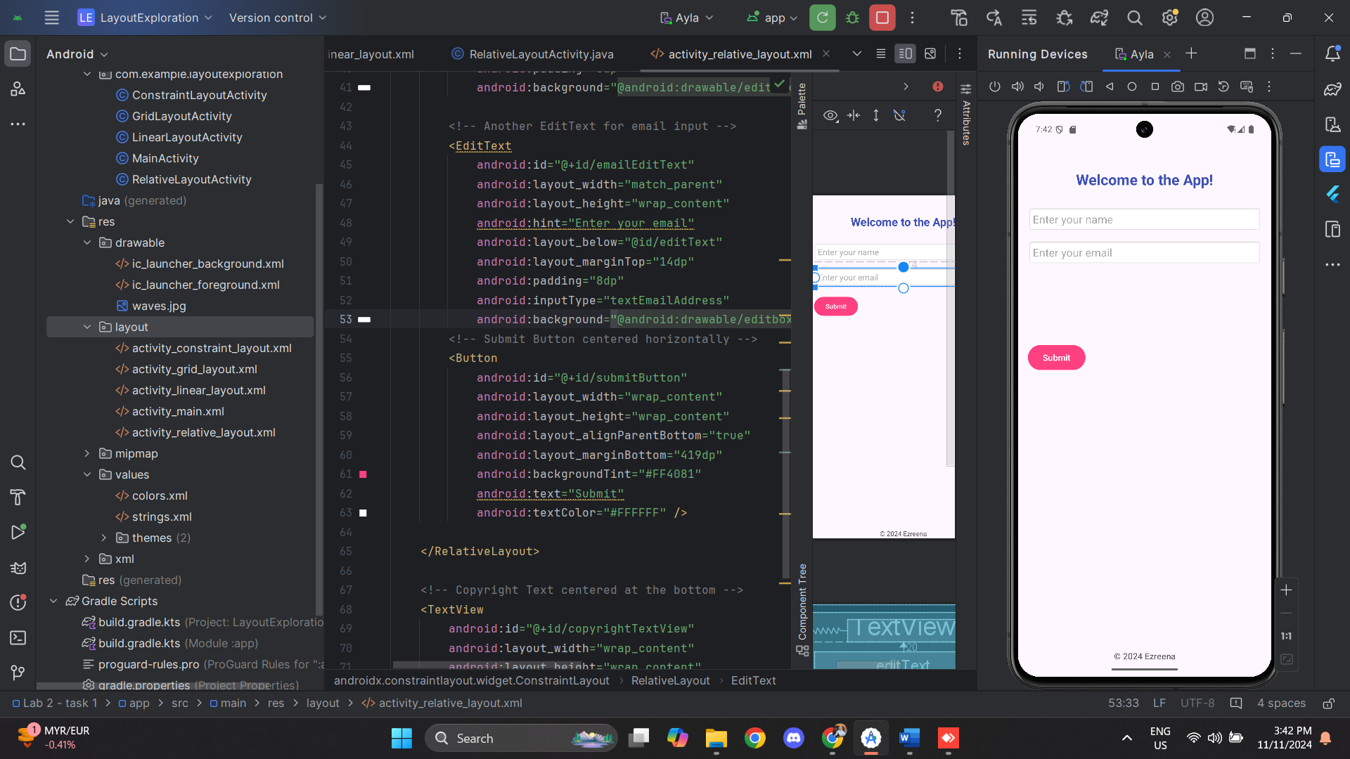

Constraint.java

|  |
| --- |
| package com.example.layoutexploration;  import android.os.Bundle;  import androidx.activity.EdgeToEdge; import androidx.appcompat.app.AppCompatActivity; import androidx.core.graphics.Insets; import androidx.core.view.ViewCompat; import androidx.core.view.WindowInsetsCompat;  public class ConstraintLayoutActivity extends AppCompatActivity {   @Override  protected void onCreate(Bundle savedInstanceState) {  super.onCreate(savedInstanceState);  EdgeToEdge.*enable*(this);  setContentView(R.layout.*activity_constraint_layout*);  ViewCompat.*setOnApplyWindowInsetsListener*(findViewById(R.id.*main*), (v, insets) -> {  Insets systemBars = insets.getInsets(WindowInsetsCompat.Type.*systemBars*());  v.setPadding(systemBars.left, systemBars.top, systemBars.right, systemBars.bottom);  return insets;  });  } } |

Activity_ConstraintLayout.xml

|  |
| --- |
| <?xml version="1.0" encoding="utf-8"?> <androidx.constraintlayout.widget.ConstraintLayout xmlns:android="http://schemas.android.com/apk/res/android"  xmlns:app="http://schemas.android.com/apk/res-auto"  xmlns:tools="http://schemas.android.com/tools"  android:id="@+id/main"  android:layout_width="match_parent"  android:layout_height="match_parent"  android:padding="16dp"  tools:context=".ConstraintLayoutActivity">   <!-- "Go Back" Button positioned at the top-left beside the title -->  <Button  android:id="@+id/goBackButton"  android:layout_width="wrap_content"  android:layout_height="wrap_content"  android:backgroundTint="#FF4081"  android:onClick="finish"  android:text="Go Back"  android:textColor="#FFFFFF"  app:layout_constraintTop_toTopOf="parent"  app:layout_constraintStart_toStartOf="parent"  android:layout_marginEnd="8dp"/>   <!-- Title TextView centered horizontally and vertically -->   <!-- EditText for user name input below the title TextView -->   <TextView  android:id="@+id/constraintText"  android:layout_width="wrap_content"  android:layout_height="wrap_content"  android:layout_marginTop="116dp"  android:text="This is Constraint Layout"  android:textColor="#3F51B5"  android:textSize="24sp"  android:textStyle="bold"  app:layout_constraintBottom_toBottomOf="parent"  app:layout_constraintEnd_toEndOf="parent"  app:layout_constraintHorizontal_bias="0.0"  app:layout_constraintStart_toStartOf="parent"  app:layout_constraintTop_toTopOf="parent"  app:layout_constraintVertical_bias="0.0" />   <EditText  android:id="@+id/nameEditText"  android:layout_width="0dp"  android:layout_height="wrap_content"  android:hint="Enter your name"  android:padding="10dp"  android:background="@android:drawable/editbox_background"  app:layout_constraintTop_toBottomOf="@id/constraintText"  app:layout_constraintStart_toStartOf="parent"  app:layout_constraintEnd_toEndOf="parent"  android:layout_marginTop="16dp"/>   <!-- Copyright Text centered at the very bottom -->  <TextView  android:id="@+id/copyrightTextView"  android:layout_width="wrap_content"  android:layout_height="wrap_content"  android:text="© 2024 Ezreena"  android:textSize="14sp"  android:textColor="#808080"  app:layout_constraintBottom_toBottomOf="parent"  app:layout_constraintStart_toStartOf="parent"  app:layout_constraintEnd_toEndOf="parent"  android:layout_marginBottom="16dp"/>  </androidx.constraintlayout.widget.ConstraintLayout> |

Output:

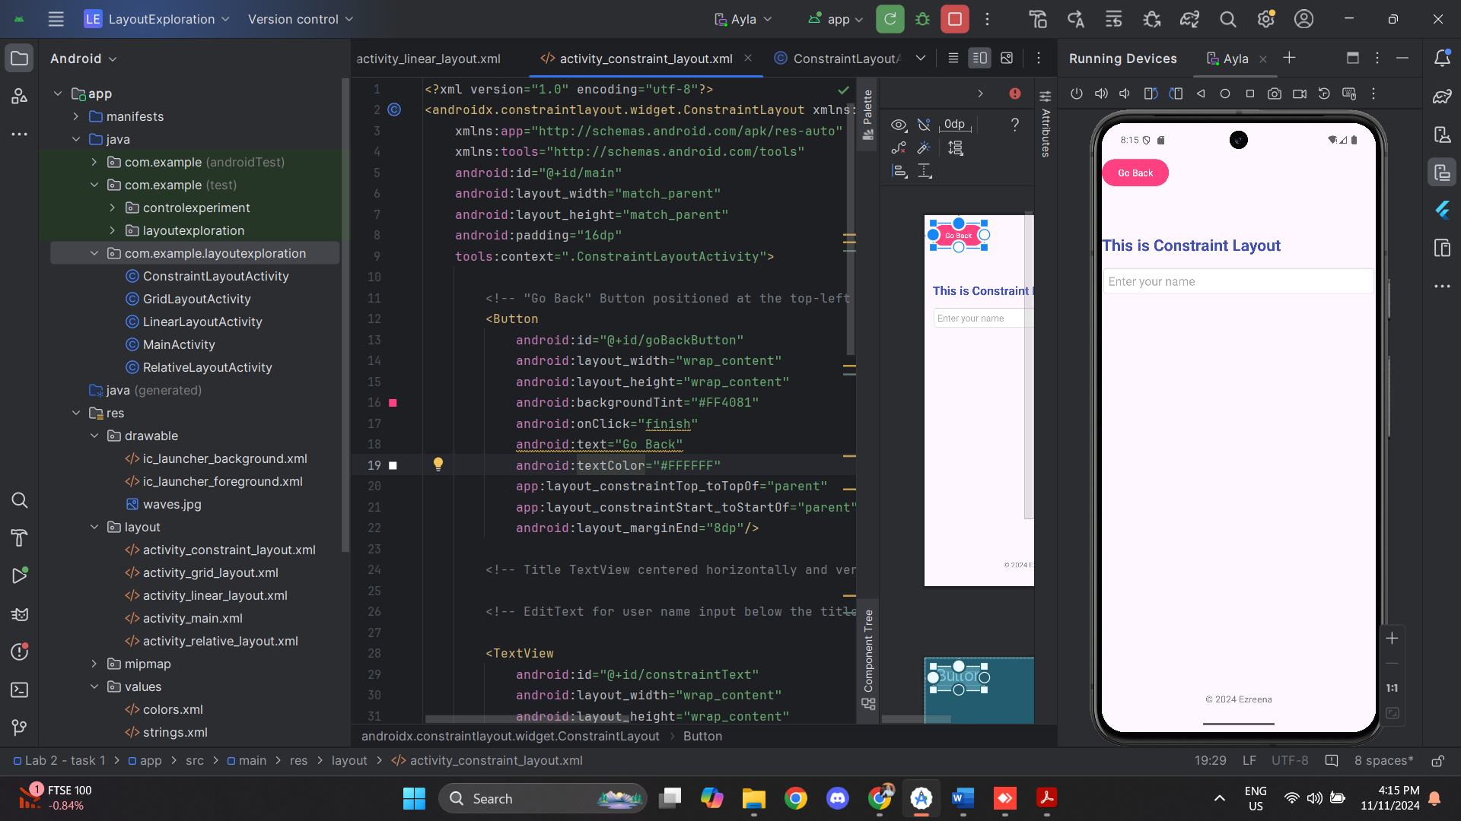

GridLayout.java

|  |
| --- |
| package com.example.layoutexploration;  import android.os.Bundle;  import androidx.activity.EdgeToEdge; import androidx.appcompat.app.AppCompatActivity; import androidx.core.graphics.Insets; import androidx.core.view.ViewCompat; import androidx.core.view.WindowInsetsCompat;  public class GridLayoutActivity extends AppCompatActivity {   @Override  protected void onCreate(Bundle savedInstanceState) {  super.onCreate(savedInstanceState);  EdgeToEdge.*enable*(this);  setContentView(R.layout.*activity_grid_layout*);  ViewCompat.*setOnApplyWindowInsetsListener*(findViewById(R.id.*main*), (v, insets) -> {  Insets systemBars = insets.getInsets(WindowInsetsCompat.Type.*systemBars*());  v.setPadding(systemBars.left, systemBars.top, systemBars.right, systemBars.bottom);  return insets;  });  } } |

Activity_GridLayout.xml

|  |
| --- |
| <?xml version="1.0" encoding="utf-8"?> <androidx.constraintlayout.widget.ConstraintLayout xmlns:android="http://schemas.android.com/apk/res/android"  xmlns:app="http://schemas.android.com/apk/res-auto"  xmlns:tools="http://schemas.android.com/tools"  android:id="@+id/main"  android:layout_width="match_parent"  android:layout_height="match_parent"  tools:context=".GridLayoutActivity">   <GridLayout  android:layout_width="match_parent"  android:layout_height="0dp"  android:layout_marginTop="16dp"  android:rowCount="3"  android:columnCount="2"  android:padding="16dp"  app:layout_constraintTop_toTopOf="parent"  app:layout_constraintBottom_toTopOf="@id/copyrightTextView">   <!-- TextView with added padding -->  <TextView  android:layout_width="wrap_content"  android:layout_height="wrap_content"  android:text="This is Grid Layout"  android:textSize="24sp"  android:layout_gravity="start|top"  android:layout_columnSpan="2"  android:padding="16dp" />   <!-- Centered Button 1 -->  <Button  android:layout_width="wrap_content"  android:layout_height="wrap_content"  android:text="Button 1"  android:layout_gravity="center"  android:layout_row="1"  android:layout_column="0" />   <!-- Centered Button 2 -->  <Button  android:layout_width="wrap_content"  android:layout_height="wrap_content"  android:text="Button 2"  android:layout_gravity="center"  android:layout_row="1"  android:layout_column="1" />   <!-- Centered Button 3 -->  <Button  android:layout_width="wrap_content"  android:layout_height="wrap_content"  android:text="Button 3"  android:layout_gravity="center"  android:layout_row="2"  android:layout_column="0" />   <!-- Go Back Button -->  <Button  android:layout_width="wrap_content"  android:layout_height="wrap_content"  android:text="Go Back"  android:onClick="finish"  android:layout_gravity="center"  android:layout_row="2"  android:layout_column="1" />  </GridLayout>   <TextView  android:id="@+id/copyrightTextView"  android:layout_width="wrap_content"  android:layout_height="wrap_content"  android:text="© 2024 Ezreena"  android:textSize="14sp"  android:layout_marginBottom="16dp"  app:layout_constraintBottom_toBottomOf="parent"  app:layout_constraintStart_toStartOf="parent"  app:layout_constraintEnd_toEndOf="parent"/> </androidx.constraintlayout.widget.ConstraintLayout> |

Output:

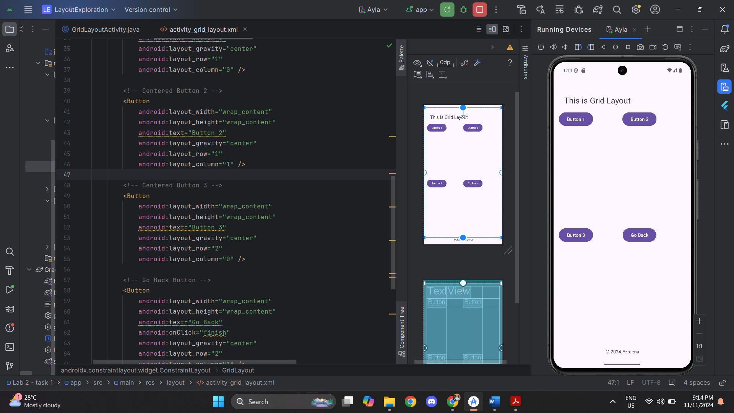

**Task 2 – ControlExperiment**

MainActivity.java

|  |
| --- |
| package com.example.controlexperiment;  import android.os.Bundle;  import android.widget.ArrayAdapter;  import android.widget.CheckBox;  import android.widget.EditText;  import android.widget.RadioButton;  import android.widget.RadioGroup;  import android.widget.Spinner;  import android.widget.Switch;  import android.widget.Button;  import android.widget.Toast;  import android.widget.ImageButton;  import androidx.appcompat.app.AlertDialog;  import androidx.appcompat.app.AppCompatActivity;  public class MainActivity extends AppCompatActivity {  @Override  protected void onCreate(Bundle savedInstanceState) {  super.onCreate(savedInstanceState);  setContentView(R.layout.activity_main);  // Initialize UI elements  EditText editText = findViewById(R.id.editText);  Button button = findViewById(R.id.button);  CheckBox checkBox = findViewById(R.id.checkBox);  RadioGroup radioGroup = findViewById(R.id.radioGroup);  Spinner spinner = findViewById(R.id.spinner);  Switch switchControl = findViewById(R.id.switchControl);  ImageButton imageButton = findViewById(R.id.imageButton);  // Set up spinner data  String[] options = {"Option A", "Option B", "Option C"};  ArrayAdapter<String> adapter = new ArrayAdapter<>(this,  android.R.layout.simple_spinner_item, options);  adapter.setDropDownViewResource(android.R.layout.simple_spinner_dropdown_item);  spinner.setAdapter(adapter);  // Set Switch listener  switchControl.setOnCheckedChangeListener((buttonView, isChecked) -> {  String status = isChecked ? "Enabled" : "Disabled";  Toast.makeText(MainActivity.this, "Switch is " + status, Toast.LENGTH_SHORT).show();  });  // Set ImageButton listener  imageButton.setOnClickListener(v ->  Toast.makeText(MainActivity.this, "Camera Button Clicked", Toast.LENGTH_SHORT).show()  );  // Button click listener with data validation  button.setOnClickListener(v -> {  String input = editText.getText().toString();    // Data validation with AlertDialog  if (input.isEmpty()) {  new AlertDialog.Builder(this)  .setTitle("Input Required")  .setMessage("Please enter some text before proceeding.")  .setPositiveButton("OK", (dialog, which) -> dialog.dismiss())  .show();  return;  }  boolean isChecked = checkBox.isChecked();  int selectedId = radioGroup.getCheckedRadioButtonId();  String selectedRadioText = selectedId != -1 ?  ((RadioButton) findViewById(selectedId)).getText().toString() : "None";  String selectedSpinner = spinner.getSelectedItem().toString();  // Show a Toast message with the collected input  Toast.makeText(this, "Input: " + input + "\nChecked: " + isChecked +  "\nSelected Radio: " + selectedRadioText +  "\nSelected Spinner: " + selectedSpinner, Toast.LENGTH_LONG).show();  });  }  } |

Activity_main.xml

|  |
| --- |
| <?xml version="1.0" encoding="utf-8"?> <androidx.constraintlayout.widget.ConstraintLayout xmlns:android="http://schemas.android.com/apk/res/android"  xmlns:app="http://schemas.android.com/apk/res-auto"  xmlns:tools="http://schemas.android.com/tools"  android:id="@+id/main"  android:layout_width="match_parent"  android:layout_height="match_parent"  tools:context=".MainActivity">   <LinearLayout  android:layout_width="match_parent"  android:layout_height="wrap_content"  android:orientation="vertical"  android:padding="16dp"  app:layout_constraintTop_toTopOf="parent"  app:layout_constraintStart_toStartOf="parent"  app:layout_constraintEnd_toEndOf="parent">   <TextView  android:layout_width="wrap_content"  android:layout_height="wrap_content"  android:text="Experimenting with Controls"  android:textSize="24sp"/>   <LinearLayout  android:layout_width="match_parent"  android:layout_height="wrap_content"  android:orientation="horizontal">   <EditText  android:id="@+id/editText"  android:layout_width="0dp"  android:layout_height="wrap_content"  android:layout_weight="1"  android:hint="Enter text"/>   <ImageButton  android:id="@+id/imageButton"  android:layout_width="wrap_content"  android:layout_height="wrap_content"  android:src="@android:drawable/ic_menu_camera"  android:contentDescription="Camera Button" />   </LinearLayout>   <Button  android:id="@+id/button"  android:layout_width="wrap_content"  android:layout_height="wrap_content"  android:text="Submit"/>   <CheckBox  android:id="@+id/checkBox"  android:layout_width="wrap_content"  android:layout_height="wrap_content"  android:text="Accept Terms"/>   <RadioGroup  android:id="@+id/radioGroup"  android:layout_width="match_parent"  android:layout_height="wrap_content">  <RadioButton  android:id="@+id/radioOption1"  android:layout_width="wrap_content"  android:layout_height="wrap_content"  android:text="Male"/>  <RadioButton  android:id="@+id/radioOption2"  android:layout_width="wrap_content"  android:layout_height="wrap_content"  android:text="Female"/>  </RadioGroup>   <Spinner  android:id="@+id/spinner"  android:paddingTop="25dp"  android:layout_width="match_parent"  android:layout_height="wrap_content"/>   <Switch  android:id="@+id/switchControl"  android:paddingTop="30dp"  android:layout_width="wrap_content"  android:layout_height="wrap_content"  android:text="Enable Feature" />   </LinearLayout> </androidx.constraintlayout.widget.ConstraintLayout> |

Output:

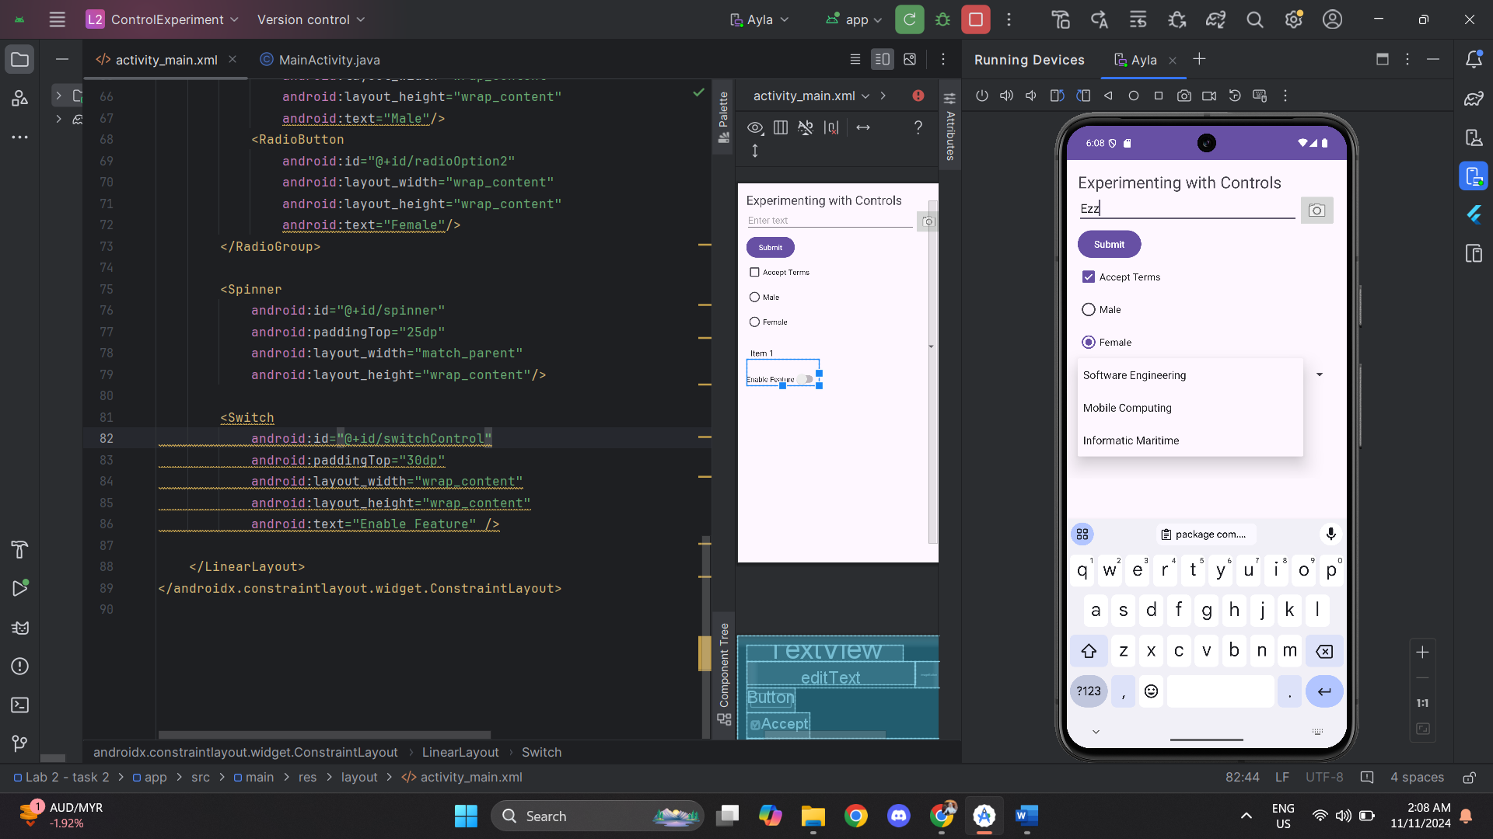 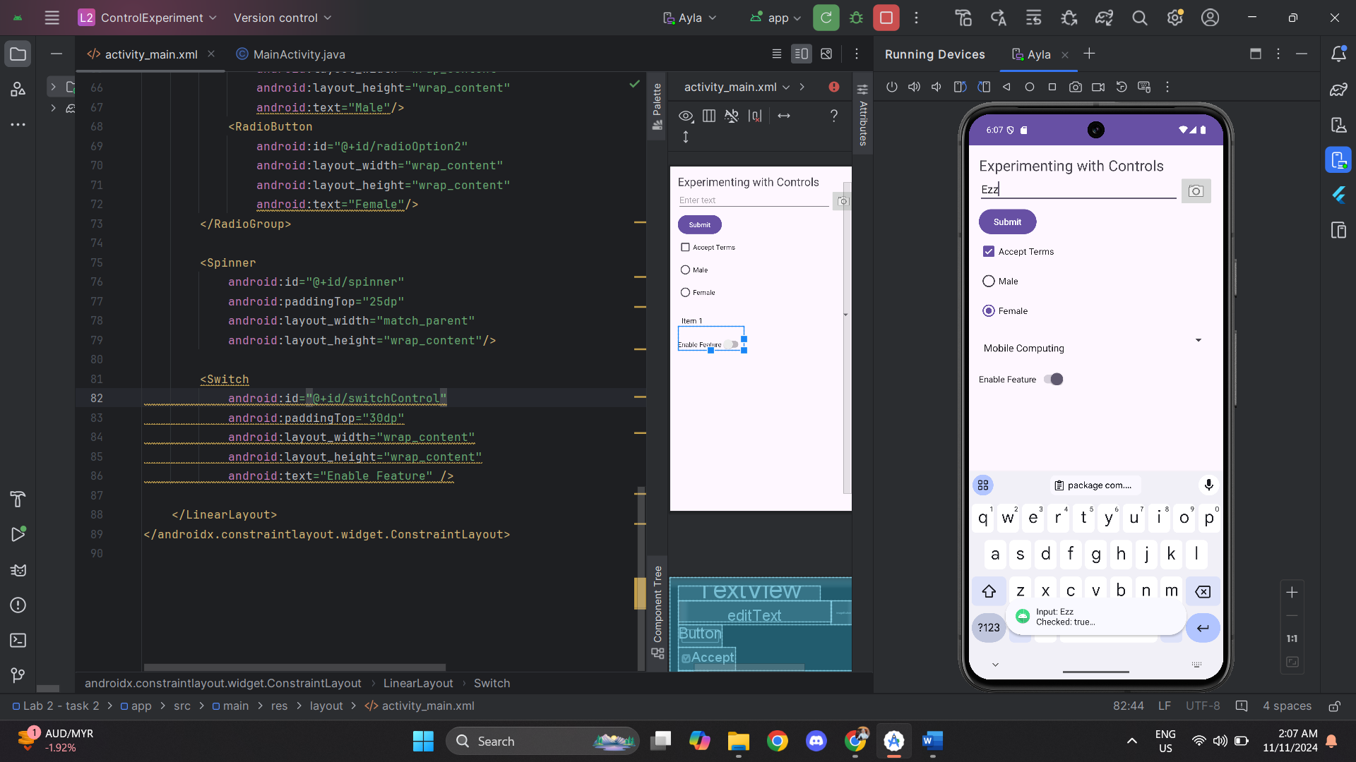

**Task 3 – SegmentedControlExperiment**

MainActivity.java

|  |
| --- |
| package com.example.segmentedcontrolexperiment;  import android.os.Bundle; import androidx.appcompat.app.AppCompatActivity; import com.google.android.material.tabs.TabLayout; import androidx.fragment.app.Fragment; import androidx.fragment.app.FragmentContainerView;  public class MainActivity extends AppCompatActivity {  @Override  protected void onCreate(Bundle savedInstanceState) {  super.onCreate(savedInstanceState);  setContentView(R.layout.*activity_main*);   TabLayout tabLayout = findViewById(R.id.*tabLayout*);  FragmentContainerView fragmentContainer = findViewById(R.id.*fragmentContainer*);   // Add tabs  tabLayout.addTab(tabLayout.newTab().setText("First Tab"));  tabLayout.addTab(tabLayout.newTab().setText("Second Tab"));   // Load the first fragment by default  if (savedInstanceState == null) {  getSupportFragmentManager().beginTransaction()  .replace(R.id.*fragmentContainer*, new FirstFragment())  .commit();  }   // Set a listener for tab selection  tabLayout.addOnTabSelectedListener(new TabLayout.OnTabSelectedListener() {  @Override  public void onTabSelected(TabLayout.Tab tab) {  Fragment fragment = null;  switch (tab.getPosition()) {  case 0:  fragment = new FirstFragment();  break;  case 1:  fragment = new SecondFragment();  break;  }  if (fragment != null) {  getSupportFragmentManager().beginTransaction()  .replace(R.id.*fragmentContainer*, fragment)  .commit();  }  }   @Override  public void onTabUnselected(TabLayout.Tab tab) {}   @Override  public void onTabReselected(TabLayout.Tab tab) {}  });  } } |

Activity_main.xml

|  |
| --- |
| <?xml version="1.0" encoding="utf-8"?> <LinearLayout xmlns:android="http://schemas.android.com/apk/res/android"  android:layout_width="match_parent"  android:layout_height="match_parent"  android:orientation="vertical"  android:padding="16dp">   <!-- TabLayout for tabs -->  <com.google.android.material.tabs.TabLayout  android:id="@+id/tabLayout"  android:layout_width="match_parent"  android:layout_height="wrap_content" />   <!-- FragmentContainerView for fragments -->  <androidx.fragment.app.FragmentContainerView  android:id="@+id/fragmentContainer"  android:layout_width="match_parent"  android:layout_height="0dp"  android:layout_weight="1" /> </LinearLayout> |

FirstFragment.java

|  |
| --- |
| package com.example.segmentedcontrolexperiment;  import android.os.Bundle; import android.view.LayoutInflater; import android.view.View; import android.view.ViewGroup; import android.widget.Button; import android.widget.ImageButton; import android.widget.TextView; import androidx.annotation.NonNull; import androidx.annotation.Nullable; import androidx.fragment.app.Fragment;  public class FirstFragment extends Fragment {   private TextView textView;  private ImageButton imageLogo;  private Button buttonChange;   @Nullable  @Override  public View onCreateView(@NonNull LayoutInflater inflater,  @Nullable ViewGroup container,  @Nullable Bundle savedInstanceState) {  // Inflate the fragment's layout  View rootView = inflater.inflate(R.layout.*fragment_first*, container, false);   // Find views by their ID  textView = rootView.findViewById(R.id.*textView*);  imageLogo = rootView.findViewById(R.id.*imageLogo*);  buttonChange = rootView.findViewById(R.id.*buttonChange*);   // Set an OnClickListener for the button to change text and hide the image  if (textView != null && imageLogo != null && buttonChange != null) {  buttonChange.setOnClickListener(v -> {  // Change the text of the TextView and center it  textView.setText("HELLO EVERYONE ITS ME NATIVE PROGRAMMING");  textView.setGravity(View.*TEXT_ALIGNMENT_CENTER*);   // Hide the image  imageLogo.setVisibility(View.*GONE*);  });  }   return rootView;  } } |

Fragment_first.xml

|  |
| --- |
| <?xml version="1.0" encoding="utf-8"?> <FrameLayout xmlns:android="http://schemas.android.com/apk/res/android"  xmlns:tools="http://schemas.android.com/tools"  android:layout_width="match_parent"  android:layout_height="match_parent"  tools:context=".FirstFragment">   <LinearLayout  android:layout_width="match_parent"  android:layout_height="match_parent"  android:gravity="center"  android:orientation="vertical">   <TextView  android:id="@+id/textView"  android:layout_width="wrap_content"  android:layout_height="wrap_content"  android:textStyle="bold"  android:text="Welcome to IT WORLD !"  android:textSize="24sp"  android:gravity="center" /> <!-- Ensure text will center within the TextView -->   <ImageButton  android:id="@+id/imageLogo"  android:layout_width="250dp"  android:layout_height="250dp"  android:layout_margin="10dp"  android:src="@drawable/wallpaper" />   <!-- Button to trigger text change and image hide -->  <Button  android:id="@+id/buttonChange"  android:layout_width="wrap_content"  android:layout_height="wrap_content"  android:padding="24dp"  android:text="Click me " />  </LinearLayout>  </FrameLayout> |

Output

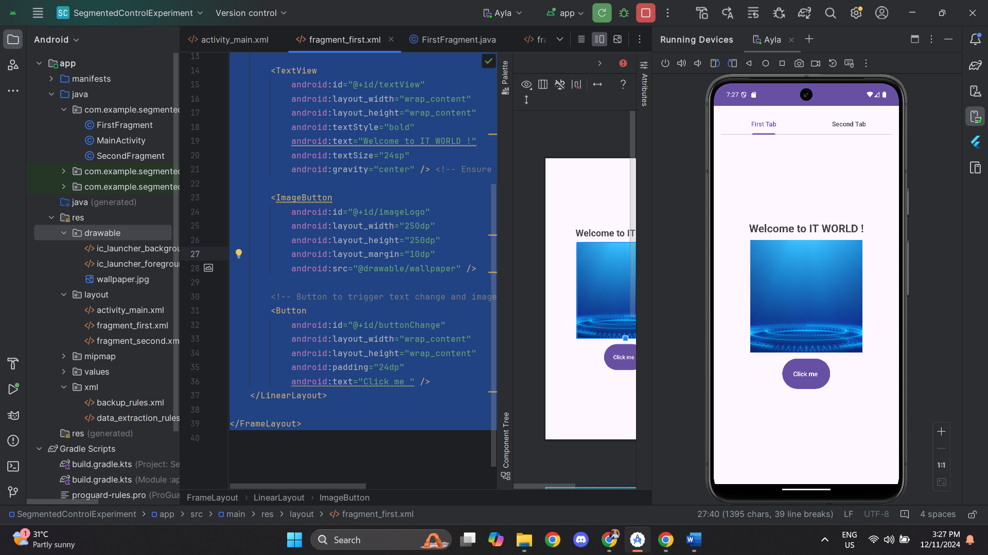: 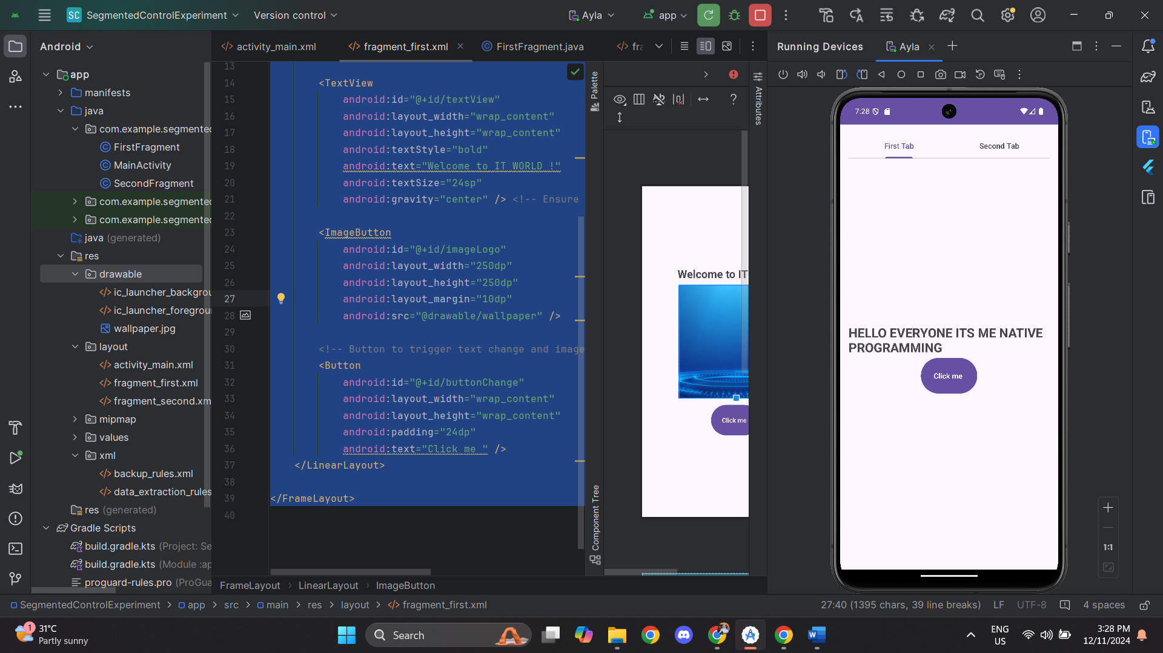

SecondFragment.java

|  |
| --- |
| package com.example.segmentedcontrolexperiment;  import android.os.Bundle; import android.view.LayoutInflater; import android.view.View; import android.view.ViewGroup; import android.widget.Button; import android.widget.EditText; import android.widget.ImageView; import android.widget.TextView; import androidx.annotation.NonNull; import androidx.annotation.Nullable; import androidx.fragment.app.Fragment;  public class SecondFragment extends Fragment {   private EditText inputField;  private Button submitButton;  private TextView displayText;  private ImageView headerImage;   @Nullable  @Override  public View onCreateView(@NonNull LayoutInflater inflater,  @Nullable ViewGroup container,  @Nullable Bundle savedInstanceState) {  View rootView = inflater.inflate(R.layout.*fragment_second*, container, false);   // Initialize views  inputField = rootView.findViewById(R.id.*inputField*);  submitButton = rootView.findViewById(R.id.*submitButton*);  displayText = rootView.findViewById(R.id.*displayText*);  headerImage = rootView.findViewById(R.id.*headerImage*);   // Set an OnClickListener for the submit button  submitButton.setOnClickListener(v -> {  String userInput = inputField.getText().toString();  if (!userInput.isEmpty()) {  // Display the entered text in displayText and make it visible  displayText.setText(" " + userInput);  displayText.setVisibility(View.*VISIBLE*);  } else {  // Prompt the user to enter something if the field is empty  displayText.setText("Please enter something!");  displayText.setVisibility(View.*VISIBLE*);  }  });   return rootView;  } } |

Fragment_second.xml

|  |
| --- |
| <?xml version="1.0" encoding="utf-8"?> <FrameLayout xmlns:android="http://schemas.android.com/apk/res/android"  xmlns:tools="http://schemas.android.com/tools"  android:layout_width="match_parent"  android:layout_height="match_parent"  tools:context=".SecondFragment">   <LinearLayout  android:layout_width="match_parent"  android:layout_height="match_parent"  android:gravity="center"  android:orientation="vertical"  android:padding="16dp">   <!-- Display an Image at the top -->  <ImageView  android:id="@+id/headerImage"  android:layout_width="200dp"  android:layout_height="200dp"  android:src="@drawable/wallpaper" />   <!-- Welcome Message -->  <TextView  android:layout_width="wrap_content"  android:layout_height="wrap_content"  android:text="Welcome to the Second Fragment"  android:textSize="20sp"  android:textStyle="bold"  android:layout_marginTop="16dp"  android:gravity="center" />   <!-- User Input Field -->  <EditText  android:id="@+id/inputField"  android:layout_width="match_parent"  android:layout_height="wrap_content"  android:hint="Type something here"  android:layout_marginTop="16dp" />   <!-- Submit Button -->  <Button  android:id="@+id/submitButton"  android:layout_width="wrap_content"  android:layout_height="wrap_content"  android:text="Submit"  android:layout_marginTop="16dp" />   <!-- Displayed TextView after submitting -->  <TextView  android:id="@+id/displayText"  android:layout_width="wrap_content"  android:layout_height="wrap_content"  android:textSize="18sp"  android:layout_marginTop="16dp"  android:visibility="gone" />  </LinearLayout> </FrameLayout> |

Output:

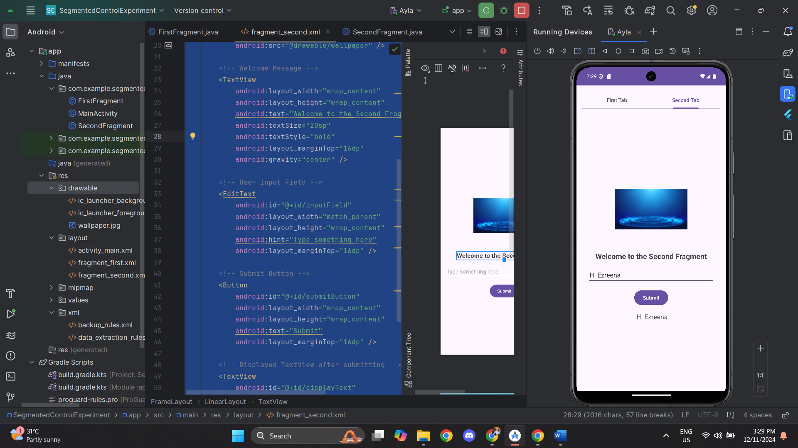

**Task 4 -ImageExperiment**

MainActivity.java

|  |
| --- |
| package com.example.imageexperiment;  import android.os.Bundle; import android.widget.Button; import android.widget.RelativeLayout; import androidx.appcompat.app.AppCompatActivity;  public class MainActivity extends AppCompatActivity {  private RelativeLayout layout;  private boolean isBackgroundOne = true;   @Override  protected void onCreate(Bundle savedInstanceState) {  super.onCreate(savedInstanceState);  setContentView(R.layout.*activity_main*);   // Corrected ID reference for RelativeLayout  layout = findViewById(R.id.*relativeLayout*);   Button switchBackgroundButton = findViewById(R.id.*switchBackgroundButton*);  switchBackgroundButton.setOnClickListener(v -> {  if (isBackgroundOne) {  layout.setBackgroundResource(R.drawable.*background2*); // Second background image  } else {  layout.setBackgroundResource(R.drawable.*background1*); // First background image  }  isBackgroundOne = !isBackgroundOne; // Toggle background state  });  } } |

Activitiy_main.xml

|  |
| --- |
| <?xml version="1.0" encoding="utf-8"?> <androidx.constraintlayout.widget.ConstraintLayout xmlns:android="http://schemas.android.com/apk/res/android"  xmlns:app="http://schemas.android.com/apk/res-auto"  xmlns:tools="http://schemas.android.com/tools"  android:id="@+id/main"  android:layout_width="match_parent"  android:layout_height="match_parent"  tools:context=".MainActivity">   <RelativeLayout  android:id="@+id/relativeLayout"  android:layout_width="match_parent"  android:layout_height="match_parent"  android:background="@drawable/background1"  app:layout_constraintBottom_toBottomOf="parent"  app:layout_constraintEnd_toEndOf="parent"  app:layout_constraintStart_toStartOf="parent"  app:layout_constraintTop_toTopOf="parent">   <!-- Image Button -->  <ImageButton  android:id="@+id/imageButton"  android:layout_width="200dp"  android:layout_height="200dp"  android:layout_centerInParent="true"  android:src="@drawable/button" />   <!-- Centered Switch Background Button Below ImageButton -->  <Button  android:id="@+id/switchBackgroundButton"  android:layout_width="wrap_content"  android:layout_height="wrap_content"  android:layout_below="@id/imageButton"  android:layout_marginTop="20dp"  android:layout_centerHorizontal="true"  android:text="Switch Background" /> </RelativeLayout>   </androidx.constraintlayout.widget.ConstraintLayout> |

Output:

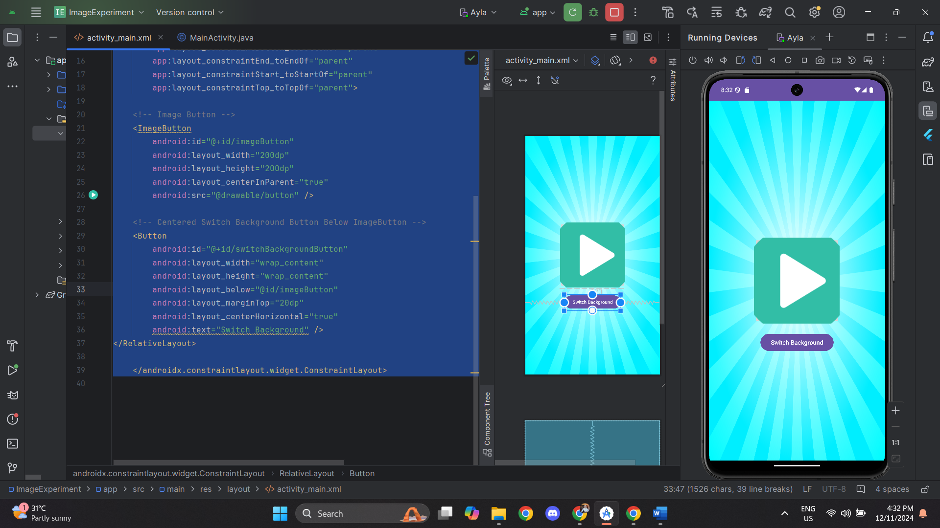 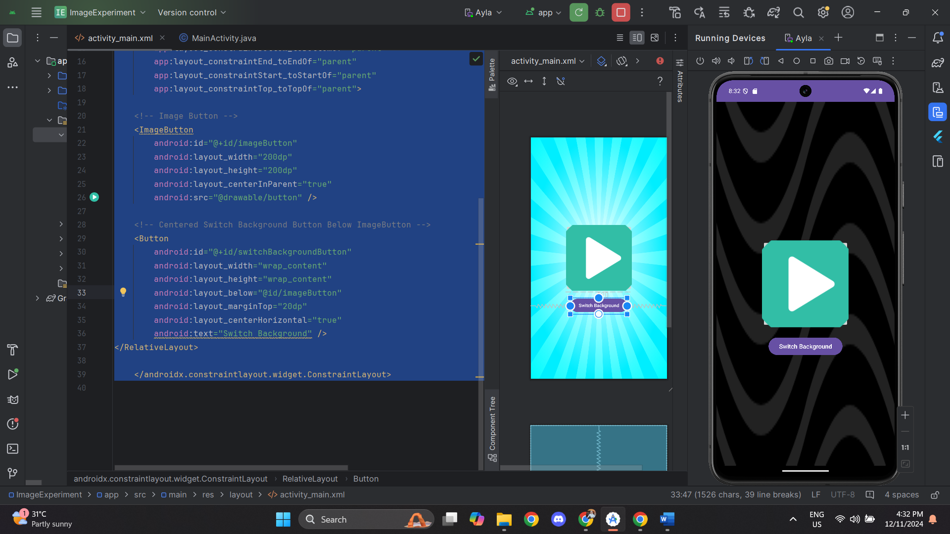

**Task 5 – MenuExperiment**

MainActivity.java

|  |
| --- |
| package com.example.menuexperiment;  import androidx.appcompat.app.AppCompatActivity; import android.os.Bundle; import android.view.ContextMenu; import android.view.Menu; import android.view.MenuItem; import android.view.View; import android.widget.TextView; import com.example.menuexperiment.R;  public class MainActivity extends AppCompatActivity {  private TextView textView;   @Override  protected void onCreate(Bundle savedInstanceState) {  super.onCreate(savedInstanceState);  setContentView(R.layout.*activity_main*);   textView = findViewById(R.id.*inputField*);  registerForContextMenu(textView); // Register context menu  }   @Override  public boolean onCreateOptionsMenu(Menu menu) {  getMenuInflater().inflate(R.menu.*main_menu*, menu);  return true;  }   @Override  public boolean onOptionsItemSelected(MenuItem item) {  int id = item.getItemId();   if (id == R.id.*action_settings*) {  textView.setText("Settings selected");  return true;  } else if (id == R.id.*action_about*) {  textView.setText("About selected");  return true;  } else {  return super.onOptionsItemSelected(item);  }  }   @Override  public void onCreateContextMenu(ContextMenu menu, View v,  ContextMenu.ContextMenuInfo menuInfo) {  super.onCreateContextMenu(menu, v, menuInfo);  getMenuInflater().inflate(R.menu.*main_menu*, menu);  menu.setHeaderTitle("Choose an option");  }   @Override  public boolean onContextItemSelected(MenuItem item) {  int id = item.getItemId();   if (id == R.id.*action_settings*) {  textView.setText("Settings selected from context menu");  return true;  } else if (id == R.id.*action_about*) {  textView.setText("About selected from context menu");  return true;  } else {  return super.onContextItemSelected(item);  }  } } |

activity_main.xml

|  |
| --- |
| <?xml version="1.0" encoding="utf-8"?> <androidx.constraintlayout.widget.ConstraintLayout  xmlns:android="http://schemas.android.com/apk/res/android"  xmlns:app="http://schemas.android.com/apk/res-auto"  android:layout_width="match_parent"  android:layout_height="match_parent">   <LinearLayout  android:layout_width="match_parent"  android:layout_height="match_parent"  android:orientation="vertical"  android:gravity="center"  android:padding="16dp">   <!-- Display an Image at the top -->  <ImageView  android:id="@+id/headerImage"  android:layout_width="200dp"  android:layout_height="200dp"  android:src="@drawable/speaker" />   <!-- Welcome Message -->  <TextView  android:layout_width="wrap_content"  android:layout_height="wrap_content"  android:text="Welcome to Ezreena Application !"  android:textSize="20sp"  android:textStyle="bold"  android:layout_marginTop="16dp"  android:gravity="center" />   <!-- User Input Field -->  <EditText  android:id="@+id/inputField"  android:layout_width="match_parent"  android:layout_height="wrap_content"  android:hint="Type something here"  android:layout_marginTop="16dp" />   <!-- Submit Button -->  <Button  android:id="@+id/submitButton"  android:layout_width="wrap_content"  android:layout_height="wrap_content"  android:text="Submit"  android:layout_marginTop="16dp" />   <!-- Displayed TextView after submitting -->  <TextView  android:id="@+id/displayText"  android:layout_width="wrap_content"  android:layout_height="wrap_content"  android:textSize="18sp"  android:layout_marginTop="16dp"  android:visibility="gone" />  </LinearLayout>  </androidx.constraintlayout.widget.ConstraintLayout> |

Main_menu.xml

|  |
| --- |
| <?xml version="1.0" encoding="utf-8"?> <menu xmlns:app="http://schemas.android.com/apk/res-auto"  xmlns:android="http://schemas.android.com/apk/res/android">  <item  android:id="@+id/action_settings"  android:title="Settings"  android:orderInCategory="100"  app:showAsAction="ifRoom" />  <item  android:id="@+id/action_about"  android:title="About"  android:orderInCategory="100"  app:showAsAction="ifRoom" /> </menu> |

Output:

